Supervisor: Kristine Freude (Mobile: + 45 2557 2261)
Research Institution: University of Copenhagen Department of Veterinary and Animal Sciences
Grønnegårdsvej 7, 1870 Frederiksberg C, 1-04.
Zones: 1, 2
First Meeting: You should arrange a meeting with your supervisor at their institution
Directions to institution (Note: It takes approximately 25-30 minutes to get to the institution from DIS):
You can take the Metro to your destination from Nørreport St. towards Vanløse (getting off at the Frederiksberg stop):
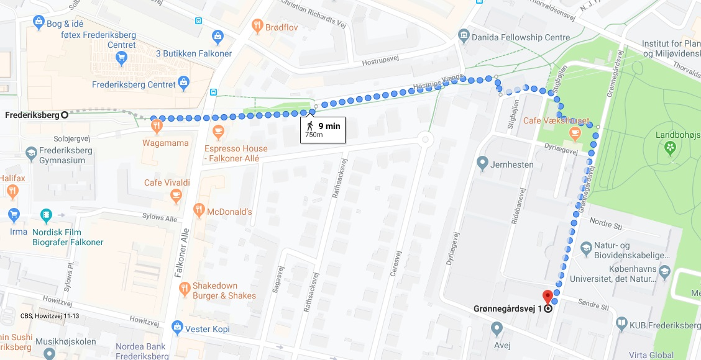

Or you can take the 2A bus from DIS to reach your destination.
To get to the institution from DIS via the 2A bus:
Walk 5 minutes from DIS to the 2A bus (headed towards Tingbjerg Gavlhusvej) at Rådhuspladsen.
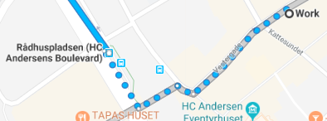
Travel from V7 towards V23, cross Rådhuspladsen

Ride 4 stops, get off at Det Biovidenskabelige Fakultet. Walk about 12 minutes to Grønnegårdsvej 7.
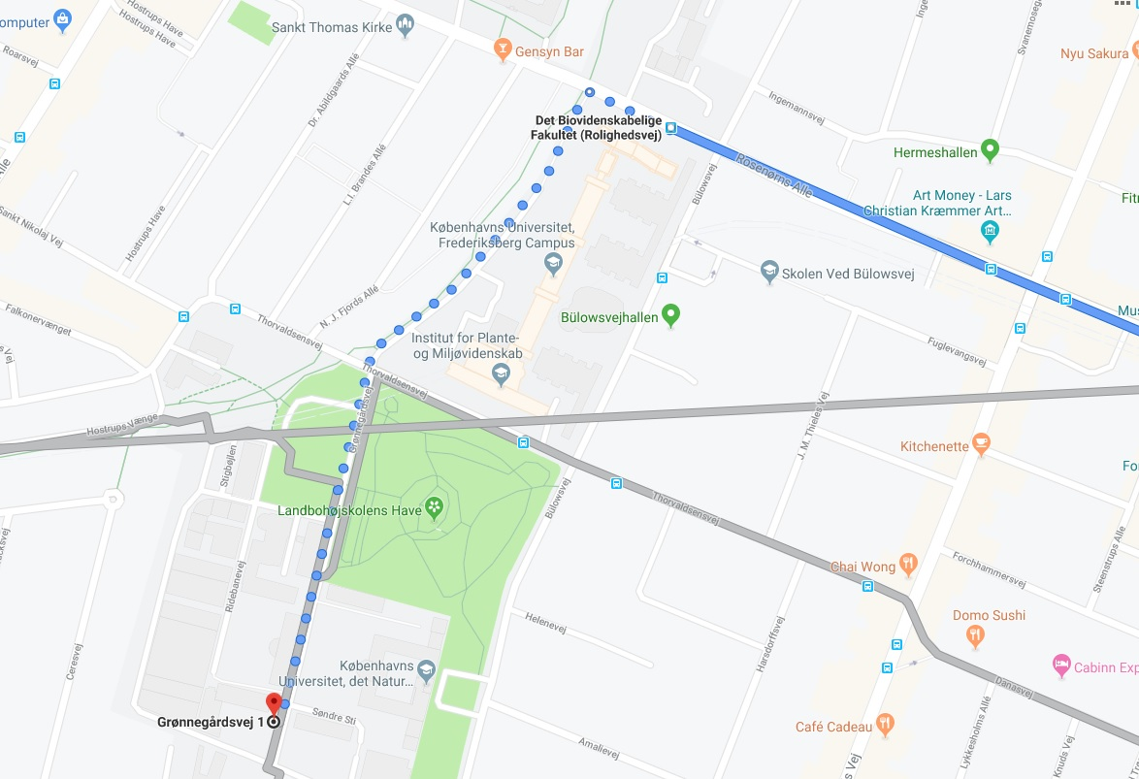

From bus stop, walk along Rolighedsvej, turning left on the path towards Grønnegårdsvej. Walk this path through Landbohojskolens Have. Arrange with Faculty where to meet inside Grønnegårdsvej 7.

