Supervisors:
Ulrik Dixen MD (+45 2965 0733)
Copenhagen Research Institution:
Department of Cardiology, Hvidovre Hospital, Kettegård Alle 30, 2650 Hvidovre (Hjertemedicinsk Afdeling, afsnit 253)
(Cardiovascular Section 253, Heart patient clinic – Outpatient clinic)
Zones required: 1, 2, 33
First Meeting: You should arrange a meeting with your supervisor at their institute

It is advised to leave DIS 1 hour before.
Directions to Institution:
Walk 5 minutes from DIS to bus 1A stop (Stormbroen, Nationalmuseet) towards Avedøre
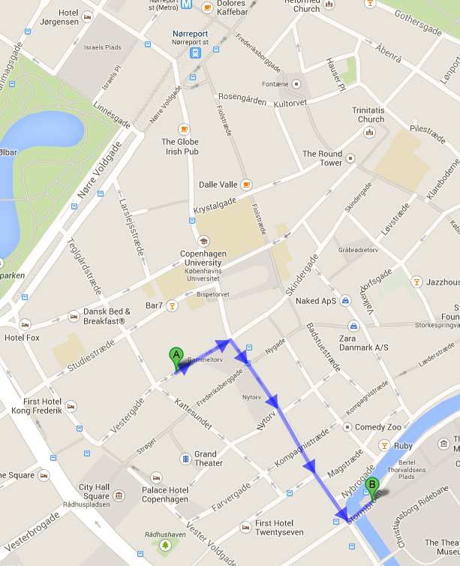

Transportation
The following routes are recommended to get to Hvidovre Hospital:
- Bus: 1A,22,200S stops at Kettegård alle, Hvidovre Hospital
- Bus: 132,133 stops at Hvidovrevej, 5 min walk to Hvidovre Hospital

