Supervisors: Dan Klærke and Associate Professor Kirstine Callø
Contact information:
Kristine Callø +45 61 66 64 02 Kristinec@sund.ku.dk
Dan Arne Klære +45 28 75 75 69 dk@sund.ku.dk

Copenhagen Research Institution:
Department of veterinary and Animal Science, University of Copenhagen
Physiology and Nutrition
1st floor, Room A11
Dyrlægevej 100
1870 Frederiksberg C

Zones required: 1, 2

First Meeting: Arrange a meeting with your advisor at their institute

It is advised to leave DIS 20-30 minutes before you plan to meet at your location

Directions to Institution:
Walk 5 minutes from DIS to the 2A bus at Rådhuspladsen.
Take the 2A bus (direction: Tingbjerg Gavlhusvej)
Ride 4 stops, get off at Det Biovidenskabelige Fakultet
Walk 6 minutes to Dyrlægevej 100
Arrange with faculty where to meet inside Dyrlægevej

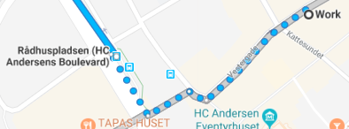
Travel from V7 towards V23, cross Rådhuspladsen
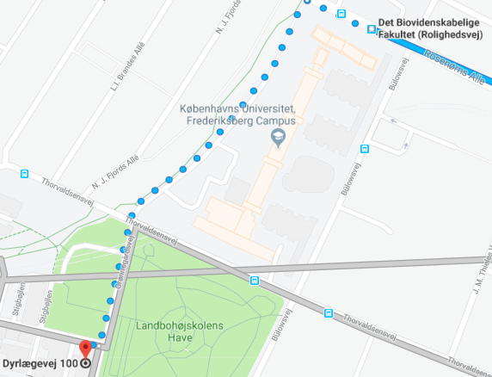
From bus stop, walk along Rolighedsvej, turning left on the path towards Grønnegårdsvej. Walk this path through Landbohojskolens Have. Arrange with Faculty where to meet inside Dyrlægevej
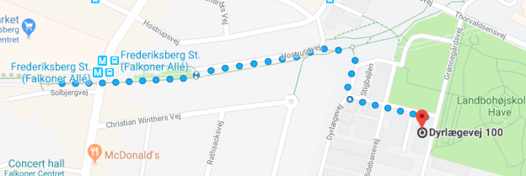
Alternatively, take the Metro from Nørreport St. towards Vanløse. Get off at Frederiksberg station and walk 6 minutes to Dyrlægevej

