Supervisors: Troels Wesenberg Kjær, M.D., Ph.D. (Mobile +45 28 40 11 33)
Copenhagen Research Institution:
Department of Neurology, Roskilde University Hospital

Zones required: 1, 2, 8, 32, 43, 54, 66, 76
First Meeting: You should arrange a meeting with your supervisor at their institution
Directions to Institution (Note: it takes approximately 45-60 minute commute from DIS):
Meeting Location: Roskilde Hospital, Vestermarksvej 11, ground floor, at the end of the red line in the floor
Directions:
Walk to Kobehavn Central Station.
Take either the Regional train (towards Ringsted St.) or IC (towards Esbjerg St)
From Roskilde Station, walk to Roskilde University Hospital.
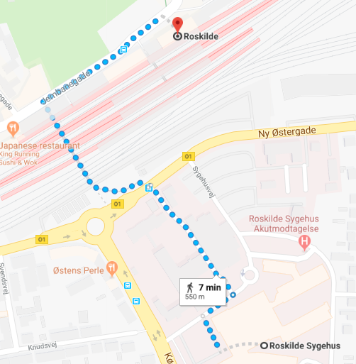
You can walk through the tunnel under the tracks to reach the other side of the train station. The hospital will be across the road from there.

Map of the Roskilde University Hospital

- 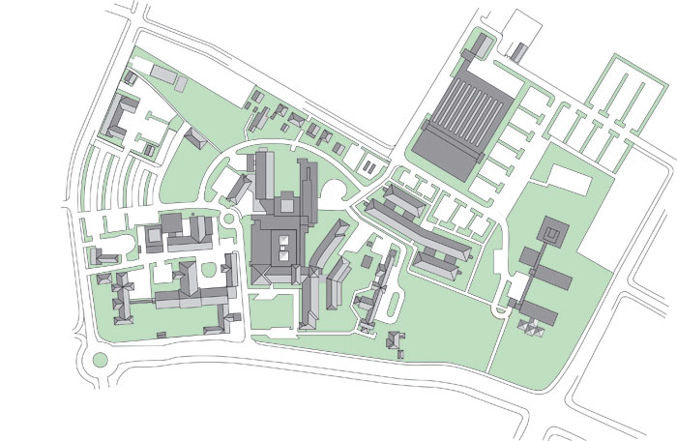
To Train Station

