Will Videos Heat Up Stockholm?

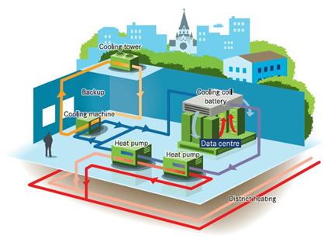

According to Cisco the annual global ip traffic will increase threefold over the next five years and reach 4,8 zettabytes in 2022. Of this traffic 82% will be videos. This would mean 3,9 zettabytes of video traffic on internet. The increase in internet traffic also means that more and more data centers must be built. Sweden is very attractive for data center investments for several reasons. Sweden is a safe country, it has hydro power, extened optical fiber network and also a low energy tax especially for data centers. Facebook built a datacenter in Luleå and is currently expanding it. Amazon Web Services (AWS), has three datacenters near Stockholm nearing completion, Google Cloud Platform (GCP), has recently acquired 109 hectares of land in Avesta and Microsoft has acquired 130 hectares of land in Gävle for building datacenters.

The increase in global ip traffic will also increase the demand for electricity. According to KTH the global ip traffic is currently using 10% of the total electricity in the world so approximately 2 500 TWh per year. By comparison the total renewable electricity production was 2 100 TWh per year in 2017. Facebook has announced that it will purchase 100 percent renewable energy and reduce their greenhouse gas emissions by 75 percent by 2020 for their datacenters. So more and more of the renewable energy would be consumed by datacenters.

There is one tiny little thing that is often forgotten when these investments are mentioned. It is that datacenters must be cooled down and in that process a lot of waste heat is produced. And I really mean a lot of heat. The size of a datacenter is defined in MW and in Sweden a datacenter of 1 MW will produce enough waste heat to heat up 1000 apartments if we can recover that heat. This can be done in cities with district heating like in Stockholm. But if you build the datacenter far outside the city, then all this waste heat is lost. Unfortunately this has happened with datacenter investments in Sweden. In Skellefteå a new data park is launched which will have a capacity of up to 120 MW and will run solely on renewable energy. It will be located on land owned by Skellefteå Kraft, next to a hydro power plant in Finnfors, Skellefteå. This village has less than 200 inhabitants, while the waste heat could heat up 120 000 apartments. The case is similar in the other large data center investments mentioned above.

Stockholm will need to build 140 000 new apartments until 2030, so could these be heated up with waste heat from datacenters? Actually it could. Stockholm Exergi launched a service called open district heating to recover excess heat from datacenters. Open District Heating enables customer to gain revenue on its excess heat that otherwise have been wasted and it was launched to market 2014. Today it has 30 customers and during 2018 a total amount of 113 GWh heat was recovered, corresponding heating of 31 000 apartments p.a. In the GrowSmarter project heat is recovered from GleSYS’s data center in Västberga in the southern part of Stockholm. Two heat pumps were installed in June -17. The heat pumps (Carrier 61XWH-ZE0501) are the first of its kind in Sweden with a heat output temperature of 85 °C and with refrigerant HFO R1234ze that reduces the environmental impact compared to traditional refrigerants.

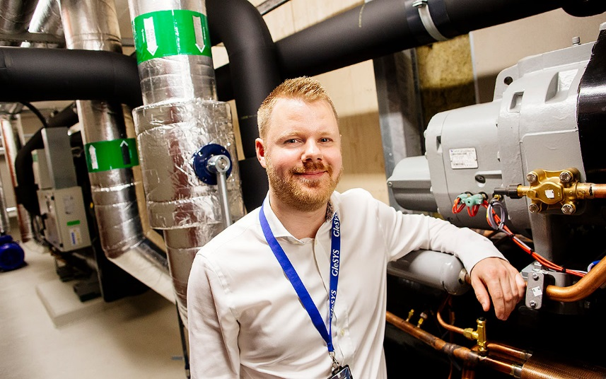

We have now evaluated this installation both technically and economically. For Stockholm Exergi the recovered heat has been cost efficient compared to other production units. For a large-scale implementation of heat recovery into the district heating network Stockholm Exergi gains other values such as avoided peak production capacity investments and reduced operation and maintenance costs thanks to third party ownership of the production asset. For the data center, Glesys, heat recovery generates a revenue stream from the waste heat that otherwise would drive cost to get rid of. Since Glesys had expansion plans for the data center with an investment need in more cooling capacity. Instead of another conventional cooling machine this heat pump solution with heat recovery was chosen. Comparing these two options this measure shows economical gains for the supplier compared to conventional data center cooling. Pay-back for the supplier will be within 5 years’ time but the economical values will sustain over the total technical lifetime of approximately 15-25 years.

If we do want to heat up the new apartments with waste heat from datacenters, Stockholm needs to attract investments into the city. Stockholm Data Parks is an initiative by the City of Stockholm, district heating and cooling provider Stockholm Exergi, power grid operator Ellevio and dark fiber provider Stokab. The vision is a data center industry where no heat is wasted. The City’s objective is to be entirely fossil fuel free by 2040, and invite data centers to play a key role in this transition. IP-Only Enterprise is one of the companies now investing in Stockholm Data Park. The data center size will be approximately 24 MW and this can heat up 24 000 apartments in 2022.

So to answer my question internet videos actually could heat up most of the 140 000 new apartments built in Stockholm until 2030, that is if datacenters investments would happen to a larger extent in Stockholm where the waste heat could be recovered.

Does this sound interesting? Well why don’t you pay a visit to Stockholm for instance to the GrowSmarter final conference the 3rd December where Stockholm Exergi will present open district heating. You can look at the conference program here (add link).

Mika Hakosalo
Site Manager GrowSmarter
City of Stockholm

