General objective observation (10-15 lines)
- What happened? What did you do? Who did you talk to? Who initiated the contact? What did other people do?

Subjective reflections (10-15 lines)
- What thought and impressions have you had during the day regarding the set up, the culture, the interactions? What are you curious about?

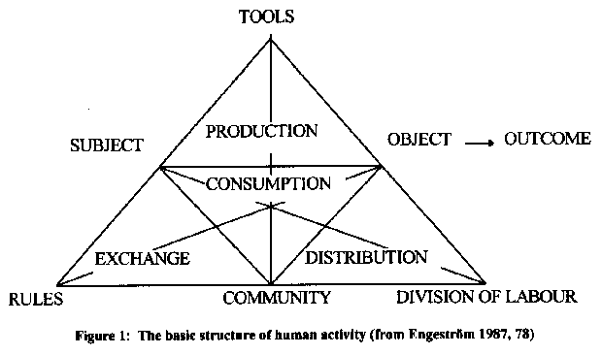
Academic reflection (10-15 lines)
- What can you say about your experiences, thoughts and impressions, using Engeströms model (see below) and the most recent reading

Looking to the future (10-15 lines)
What are your goals for the next visit? What did you do to meet your goals for the last visit? What do you do, that you need to do more of

